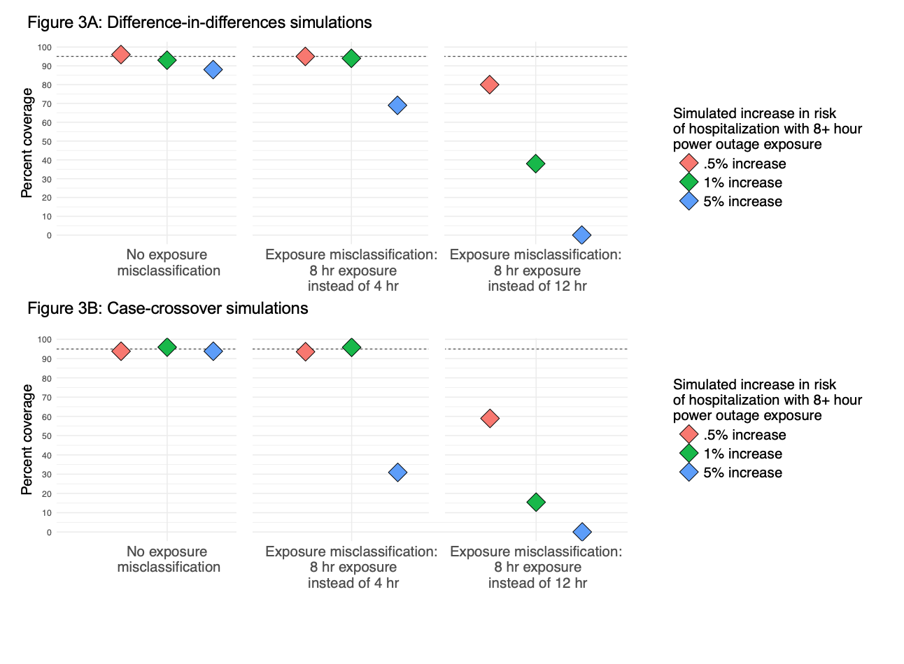**Figure 3**: Results from simulations of the association between power outage exposure and hospitalizations in 100 counties with different percentages of exposure data missing using a (A) difference-in-differences design and (B) case-crossover design. Simulations were repeated 100 times, and plots show the percent coverage of 95% confidence intervals. There is a dashed line at 95%.